**DTU V1D – DTU Vertical 1D Transport Model. A spreadsheet for risk assessment in low-permeability media**

DTU V1D calculates the leaching concentration from a low-permeability media (with or without fractures) to an underlying aquifer for two source models:

* Source overlying the low-permeability matrix (model 1a and 1b)
* Source trapped in the low-permeability matrix (model 2)

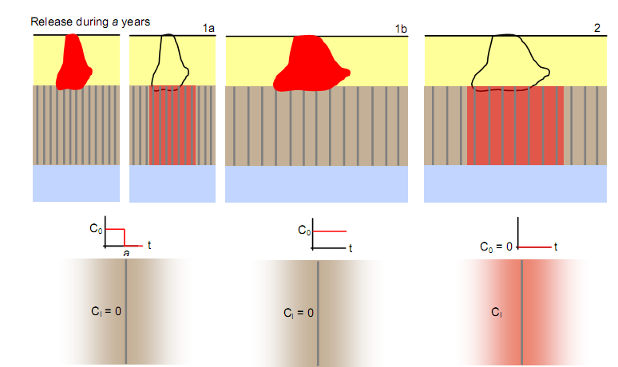

Figure – Source overlying the low-permeability media for a years (model 1a) or for an infinite time (model 1b), and source trapped in the low-permeability matrix (model 2).

DTU V1D calculates the leaching concentration using four different conceptual models:

* Presence of vertical fractures throughout the low-permeability media
  + Advection along the fractures
  + Diffusion and sorption in the porous matrix
  + Degradation in the fractures and matrix
* Equivalent Porous Media (EPM) with 1D advection/dispersion in uniform low-permeability media
  + Advection/dispersion
  + Degradation
* Diffusion only in the porous media (if the hydraulic conductivity is very low, advection is negligible and diffusion is the dominant processes in the porous media)
  + Diffusion
  + Degradation
* 1st-order model for exponentially declining source (applied for model 2 only)
  + Advection
  + Degradation
  + Decaying source
  + See Troldborg et al. (2008)

DTU V1D is suitable for fully saturated media only and does not account for gas transport. The analytical solution for leaching through fractured media, a single fracture assumption is used (see bottom schemes in Figure 1). This assumption is reasonable for large fracture spacing (>1-1.5m), as commonly found in Danish clay tills. For model 2 (source trapped in low-permeability media), the leaching concentrations for time longer than diffusion time in the matrix have to be disregarded. This is automatically done in the Excel sheet with a warning (see example below). More details on the risk assessment tool for fractured media and EPM can be found in Chambon et al. (2011).

*Calculation of hydrogeological parameters for fractured media*

The hydrogeological and transport parameters for fractured media are calculated based on two equations; Eq. (1) gives the bulk hydraulic conductivity of the fractured media (*Kb*) depending on the fracture network properties, and Eq. (2) is referred to as the cubic law, and gives the water velocity in the fracture depending on the aperture and hydraulic gradient (McKay et al., 1993):





Where *Kb* is the bulk hydraulic conductivity (m/s), *ρ* is the density of water (kg/m3), *g* is the acceleration of gravity (m/s2) and *μ* is the kinematic viscosity of water (Pa.s-1), *2b* is the fracture aperture (m), *2B* is the fracture spacing (m), *vf* is the water velocity along the fracture (m/s) and *i* is the hydraulic gradient along the fracture (-).

Furthermore the hydraulic gradient is linked to the bulk hydraulic conductivity and the net infiltration (*I*) with:



Therefore in order to get the five hydrogeological parameters (Kb, 2b, 2B, I and i), only 3 (*2B*, *Kb* or *2b* and *I* or *i*) are necessary and the others can be calculated from Eq. (1-3). This insures the consistency between the hydraulic parameters. The velocity can then be calculated using Eq. (2).

*Formula input in Excel*

The analytical solution for contaminant leaching through fractured media involves the complementary error function *erfc* (see Chambon et al., 2011 for details). In Excel the erfc function returns an error for negative arguments or for arguments above 28 (even if the function *erfc* is defined for these values), therefore another function has to be used instead (*normsdist*), with the following equivalence:



All the cells with formula in Excel are protected from changes with a password (DTUV1D), so that they cannot be changed unintentionally.

Spreadsheet organization – example for a fractured low-permeability media (overlying source for 20 years, model 1a)

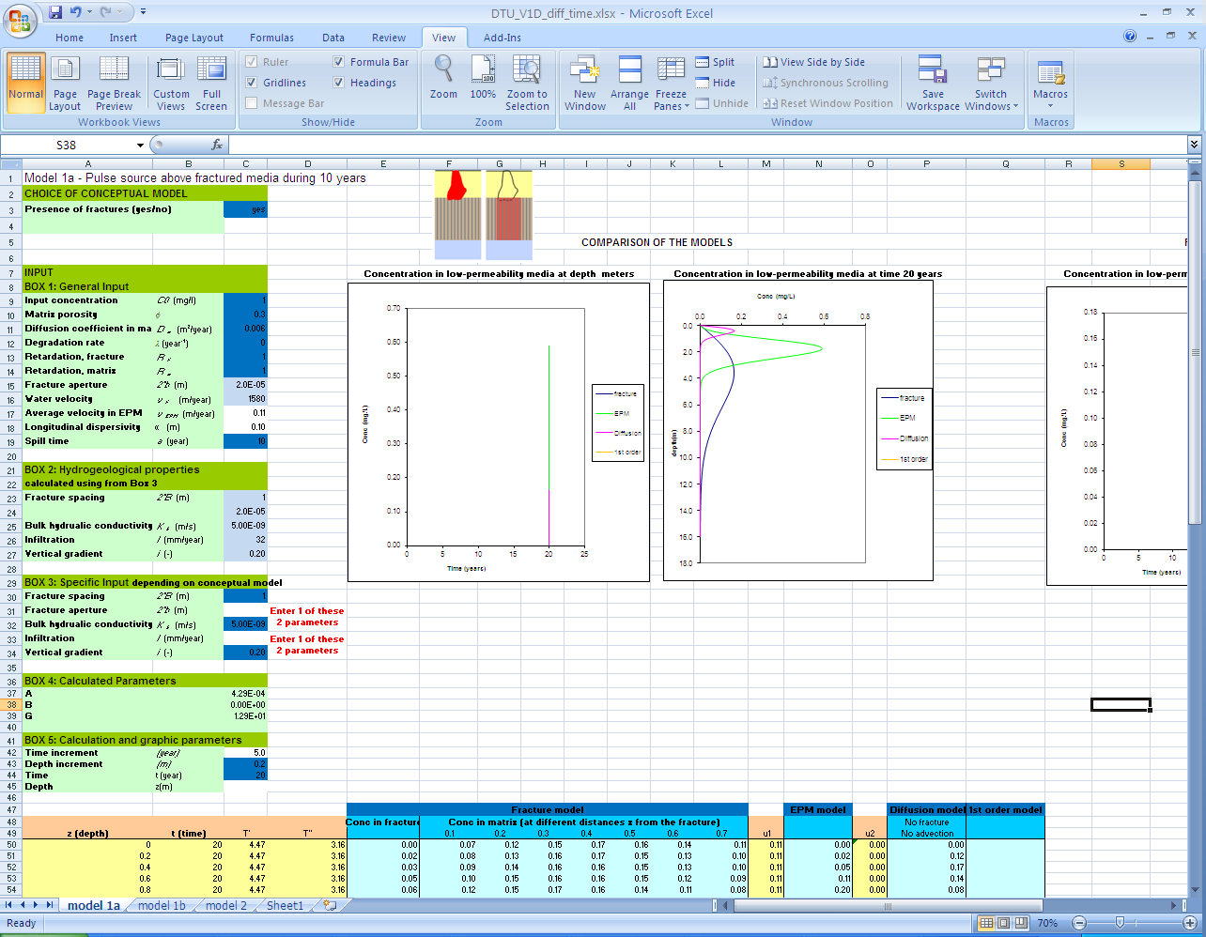

Results

Fixed time (t), concentration profile with depth

Choice of conceptual models

Input parameters used for calculations

**In dark blue, input parameters necessary for calculations and provided by the user**

**In light blue, parameters necessary for calculations and calculated from dark blue parameters**

Graphical results

Choice of the source model

Spreadsheet organization – example for a fractured low-permeability media (source trapped in the matrix, model 2)

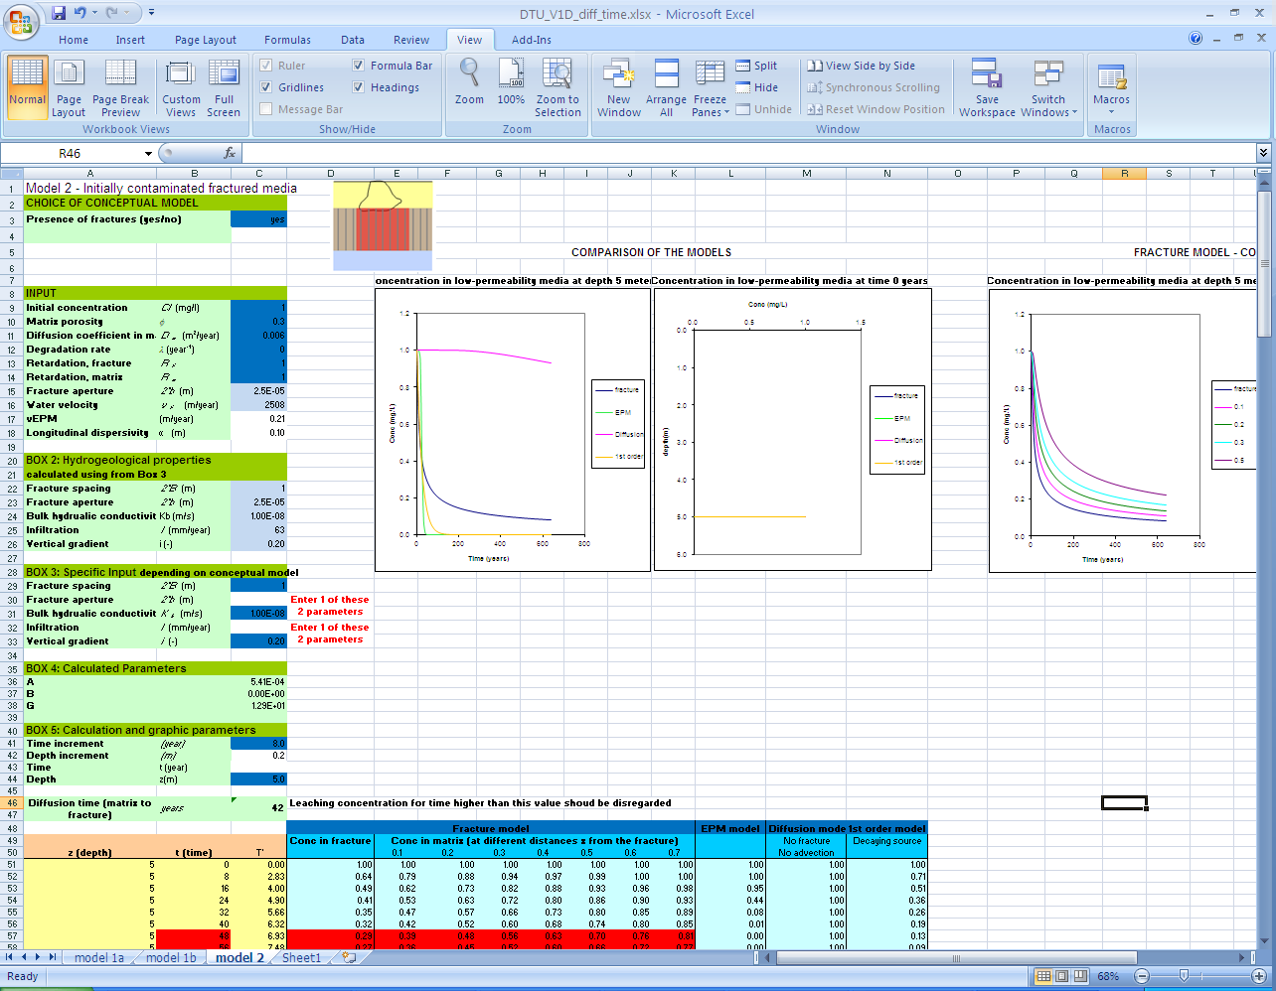

Validity of single fracture assumption – red times should be disregarded

Choice of conceptual models

Fixed depth (z), leaching concentration with time

**In light blue, parameters necessary for calculations and calculated from dark blue parameters**

**In dark blue, input parameters necessary for calculations and provided by the user**

Results

Choice of the source model

Graphical results

Input parameters used for calculations

Spreadsheet organization – example for a non-fractured low-permeability media, with advection/dispersion (overlying source for 20 years, model 1a)

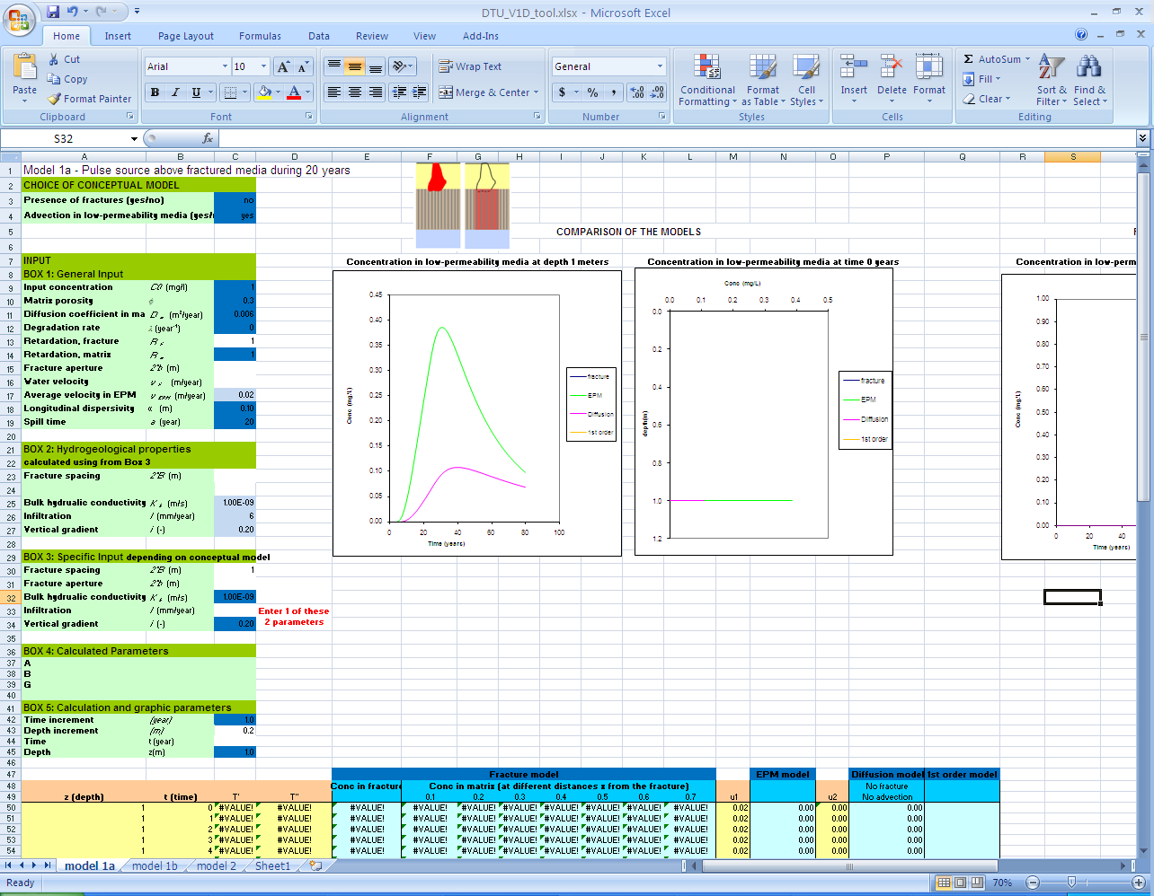

No solution for fractures

Choice of conceptual models

Input parameters used for calculations

**In dark blue, input parameters necessary for calculations and provided by the user**

**In light blue, parameters necessary for calculations and calculated from dark blue parameters**

Fixed depth (z), leaching concentration with time

Results

Graphical results

Spreadsheet organization – example for a non-fractured low-permeability media, with diffusion only (overlying source for 20 years, model 1a)

Choice of the source model

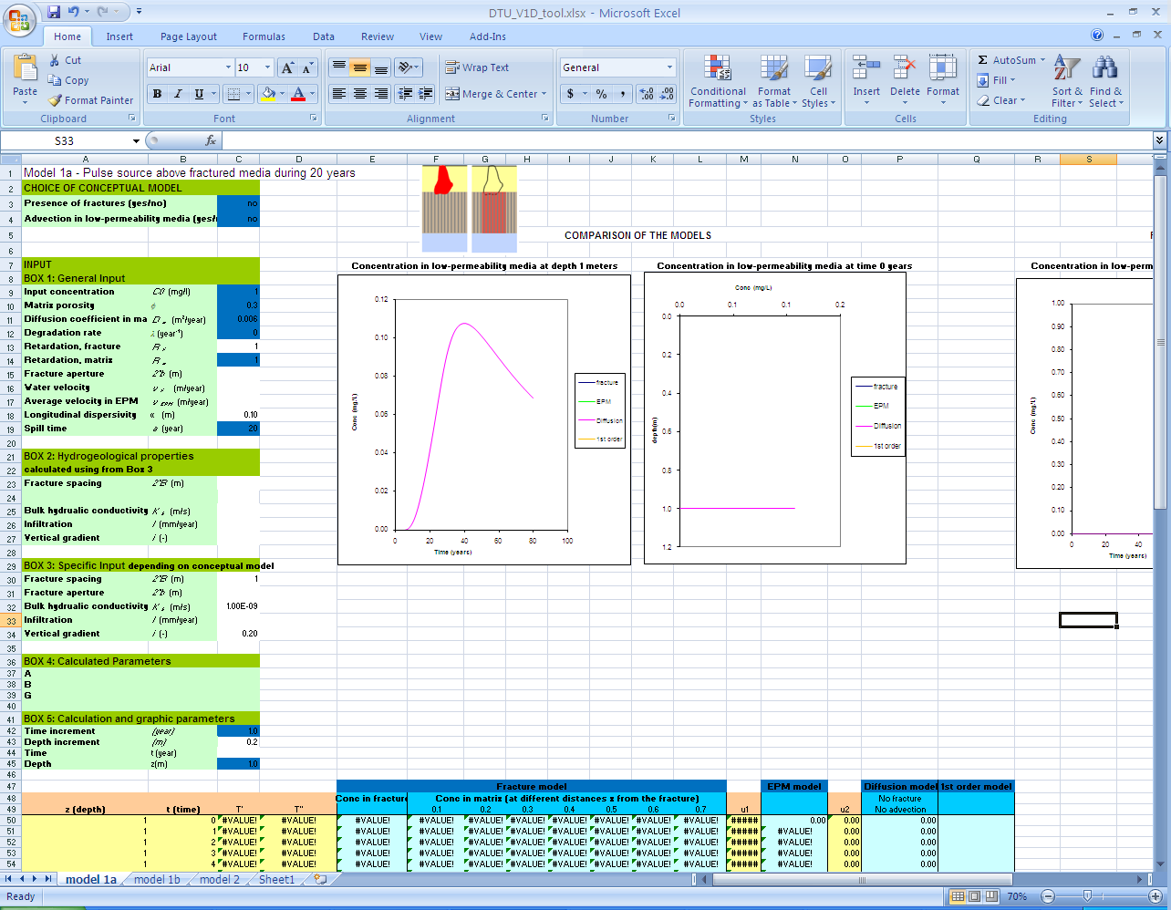

No solution for fractures and EPM

Choice of conceptual models

Input parameters used for calculations

**In dark blue, input parameters necessary for calculations and provided by the user**

**In light blue, parameters necessary for calculations and calculated from dark blue parameters**

Fixed depth (z), leaching concentration with time

Results

Graphical results

Choice of the source model

Reference List

Chambon, J. C., Binning, P. J., Jorgensen, P. R., and Bjerg, P. L., 2011. A risk assessment tool for contaminated sites in low-permeability fractured media. Journal of Contaminant Hydrology. 124 (1-4), 82-98.

McKay, L. D., Cherry, J. A., and Gillham, R. W., 1993. Field Experiments in A Fractured Clay Till .1. Hydraulic Conductivity and Fracture Aperture. Water Resources Research. 29 (4), 1149-1162.

Troldborg, M., Lemming, G., Binning, P. J., Tuxen, N., and Bjerg, P. L., 2008. Risk assessment and prioritisation of contaminated sites on the catchment scale. Journal of Contaminant Hydrology. 101 (1-4), 14-28.