|  |
| --- |
|  |
| DIMICON user guide  Program for the evaluation of Dilution/MIxing/ of CONtaminant in streams |
| 2018 |

|  |  |
| --- | --- |
| User guide  2018  By Gregory Lemaire and Poul L. Bjerg | |
| Copyright: | Reproduction of this publication in whole or in part must include the customary bibliographic citation, including author attribution, report title, etc. |
|  |  |
| Published by: | Department of Environmental Engineering, Bygningstorvet |
| Request report from: | [www.sara. env](http://www.sara. env).dtu.dk |
|  |  |
|  |  |
|  |  |

Preface

This document is a user guide for DIMICON, which is a stand-alone application for the calculation of the mixing/dilution of contaminant in streams.

The current version of DIMICON model has been developed by Greg Lemaire based on the following references:

* Aisopou et al al. (2015)
* Lemaire (2016)

The key results are prepared for the risk assessment of streams impacted by groundwater contamination from landfills (Miljøstyrelsen, 2018).

The interface has been updated with extra features by Morten Bjerg.

Lyngby, October 2018

Grégory Guillaume Lemaire

Poul L. Bjerg

Contents

1. Introduction 5

1.1 Program installation 5

1.2 Program description 5

1.3 Limitations 6

2. Program overview 8

2.1 Main interface 8

2.2 Interface menus 9

2.2.1 File menu 9

2.2.2 Tool menu 9

2.2.3 Result menu and outputs 10

# Introduction

This technical guide aims at describing the program DIMICON for the calculation of dilution and mixing of groundwater contamination discharging to a stream. The key results are prepared for the risk assessment of a stream impacted by landfill leachate (see Miljøstyrelsen 2018 for further details).

## Program installation

The program was implemented in MATLAB and it is distributed as a stand alone version that does not require a MATLAB license. The program is compatible with Microsoft Windows systems. An internet connection is required during the installation process (once the program is installed it can be used without internet).

The code is provided as an executable file. For installation, run the “dimicon.exe” file and follow the instructions.

## Program description

The program aims at estimating the mixing and dilution of a contaminant seeping from groundwater into a stream. The contaminant is uniformly discharged from the bank or for the streambed (stretch of ½ width) into the stream (see below).

flow

(2)

(1)

Figure 1. Contaminant discharge location: from bank (1) or half a streambed (2)

The model provides as an output the mixing length Lmix, i.e. the distance necessary to obtain a fully mixed condition of the contaminant, the fully mixed concentration Cmix at that particular distance as well as the maximum concentration estimated at the edge of the calculated mixing zone (denominated as Cmz), as defined in Miljøstyrelsen (2018). An output file can be exported providing the estimated contaminant concentration at discrete positions in the stream over a user defined grid for possible post-treatment (see Appendix B).

The calculation is performed by use of a steady state 2D analytical model with conservative assumptions, i.e. there is no degradation, reaction or volatilization process in play in the stream water.

More details and technical description of the model can be found in Lemaire (2016) and Aisopou et al. (2015).

Fully mixed conditions  
C = Cmix ~ Cste

**Calculated mixing zone: *10 x W***

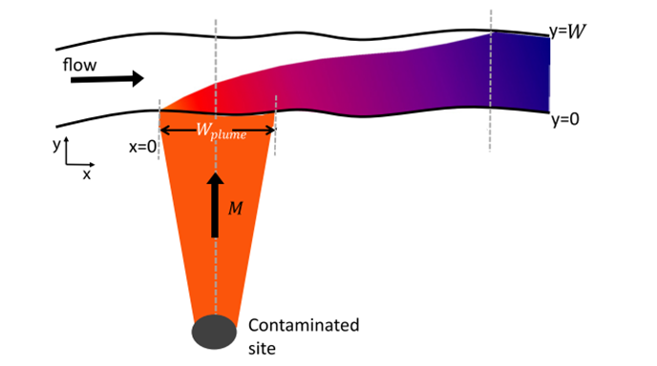

Downstream edge  
Calculated mixing zone  
C = Cmz

C = Cmax

*Lmix*

Figure 2. Schematic showing the different outputs of the model  
Stream seen from above, flowing from left to right.

## Limitations

The version of the program provided here (V2.0) cannot be used for the following purposes:

* Simulating complex distribution of contaminant in the plume, e.g. non uniform distribution
* Estimating values of concentration for contaminant undergoing signification degradation, sorption or volatilization processes in the stream.

# Program overview

## Main interface

When the program is started, the following interface should appear:

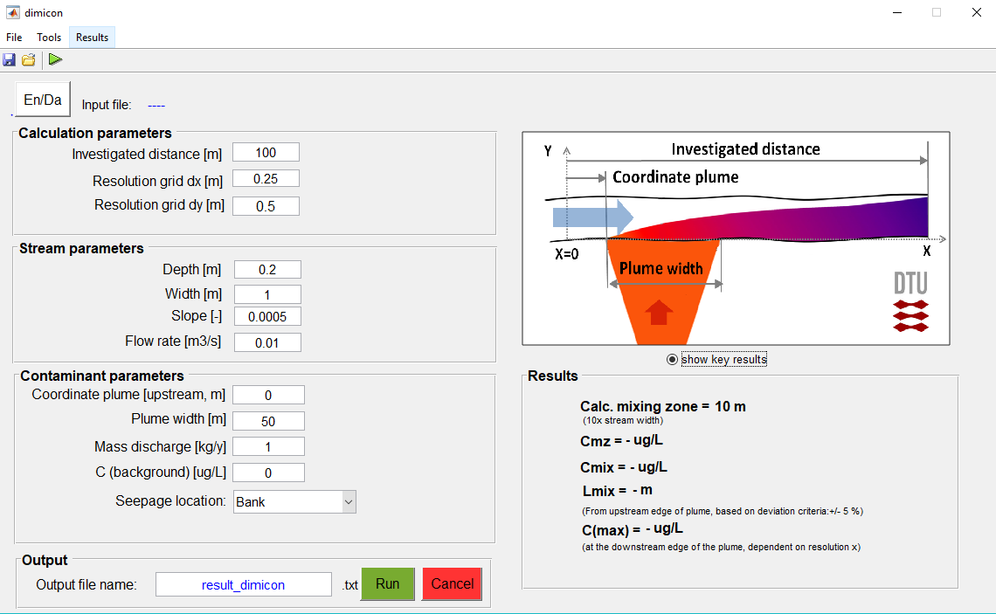

Figure 3. Main program interface.

Some initial and default values for the required parameters are provided and can be updated by the users. The required inputs are:

* Calculation domain inputs: The length of the river stretch investigated, as well as the resolution in X and Y direction, i.e. along and transverse to the stream.
* Stream parameters: the required parameters are the width, depth and slope of the stream, as well as the flow rate. Typical dimensions for Danish streams are given in Table 1.
* Contaminant parameters: The required parameters are the coordinate for the upstream point of the plume, the plume width, the plume discharge location (bank or ½ streambed, see Figure 1) and finally the contaminant mass discharge.
* Output: The name of the “.txt” output file can here be specified.

In addition

* A Danish or English version of the input text can be chosen (pres “eng/da”), however all results appear in English.

The key results can be omitted or shown as wanted (press “show key results”).

Table 1. Typical dimensions for Danish streams. Table copied from Miljøstyrelsen (2018)

|  |  |  |  |  |  |  |
| --- | --- | --- | --- | --- | --- | --- |
|  | Small stream | | Medium stream | | Large stream | |
|  | Low limit (case 1) | High limit (case 2) | Low limit (case 3) | High limit (case 4) | Low limit (case 5) | High limit (case 6) |
| Width [m] | 1 | 2 | 2 | 10 | 10 | 15 |
| Flow rate [m3/s] | 0.01 | 3 | 0.08 | 1 | 2 | 8 |
| Depth [m] | 0.2 | 1.1 | 0.5 | 0.8 | 1.25 | 2.3 |
| Slope [-] | 0.0005 | 0.01 | 0.0005 | 0.0005 | 0.0005 | 0.0005 |

The detailed list and clarification of required parameters are given in Appendix A.

*Note: The reference system is X along the river, Y in the transverse direction. The contaminant seeps in the stream from the riverbank or from the half streambed starting from the bank at Y =0, see Appendix A.*

***Note 2:The decimal separator is a point ‘.’ In the program and in the export file.***

***Note 3: For proper calculation, it is recommended that the resolution along the longitudinal direction dx is such that dx< Wplume/5. The program will automatically update the resolution to ensure the criteria is fulfilled.***

## Interface menus

### File menu

In this menu, the following options are available:

* **Save input file**: All input parameters are saved in a dedicated file “*.dil”. The name of the file is specified by the user via the dedicated popup window.
* **Load input file**: To load an input file “*.dil” previously saved. The name of the loaded file is then displayed in the interface
* **Close**: Close the program. No data is saved when the program is closed.

### Tool menu

The following submenus are available:

* **Dispersion parameters**: the values by default for these coefficients have been given by literature and validated with measurements of dispersion in different streams (Rutherford, 1994). These values are suitable for estimating dilution and mixing length in relatively straight streams and should not be modified without prior discussion with DTU.
* **Fully mixed criterion**: At fully mixed condition, the concentration in a given section of the stream is almost constant. This condition is defined in the software as a limited variation of the concentration around an average concentration. By default, a value of +/-5% of deviation of concentration in a transverse section is defined as a criteria for the fully mixed conditions (see equation 1 below). The value can be changed via this menu.

|  |  |
| --- | --- |
| $$C\left(L_{mix},y_{i}\right)∈[\overline{C\left(L_{mix},y\right)}+/- (Deviation)\%]$$ | Eq. (1) |

**Note: The mixing length is given from the most upstream point of the plume to facilitate the comparison to the mixing zone.**

### Result menu and outputs

When available, the result can be exported in a tabulated text file than can be open in Excel for further treatment. The file contains all input parameters, as well as the estimated concentration on the user-defined grid for possible post-treatment. A display of the exported file is given in appendix B. This file is available via the menu **Results > Export.**

Some outputs are also directly given in the main interface and are the followings:

* **Calculated mixing zone**: size of the calculated mixing zone, based on stream properties (see Miljøstyrelsen (2018) for more details). This calculated mixing zone is defined from the most upstream point of the contaminant plume.
* **C mz**: Gives the average concentration estimated at the downstream edge of the administrative mixing zone (see Figure 1).
* **C mix**: Estimated fully mixed concentration. Concentration estimated at the distance Lmix, based on deviation criteria (default value: +/- 5%, see section 2.2.2)
* **Lmix**: Mixing length, given from the upstream edge of the plume section is nearly constant, computed using the criteria defined in section 2.2.2.
* **C max**: Maximum concentration estimated in the stream water (reached at the downstream edge of the contaminant plume).

**Note: As a discrete analytical calculation, the different concentration values are dependent on the span given for X and Y.**

References

Aisopou, A., Bjerg, P. L., Sonne, A. T., Balbarini, N., Rosenberg, L., and Binning, P. J. (2015). Dilution and volatilization of groundwater contaminant discharges in streams. Journal of Contaminant Hydrology.172, 71-83.

Lemaire G. (2016): Seasonal variation of contaminant discharge to stream and in-mixing effect. Master thesis, DTU Environment.

Miljøstyrelsen (2018). Methodology for risk assessment of stream water contamination by landfills. Mixing of landfill leachate plumes in streams.

Rutherford, J. (1994): River mixing. Wiley

1. Appendix A Input file

|  |  |  |
| --- | --- | --- |
| **Parameters** | | **Comment** |
| **Calculation** | |  |
|  | Distance [m] | Calculation from X=0 to X= distance |
|  | Resolution grid X [m] | Grid span in the X direction (along stream) |
|  | Resolution grid Y [m] | Grid span in the Y direction (transverse stream) |
| **Stream** | |  |
|  | Width [m] | See typical values in Table 1 |
|  | Depth [m] |
|  | Slope [-] |
|  | Flow rate [m3/s] |
| **Contaminant** | |  |
|  | Plume coordinate [m] | Location of the upstream point of the plume |
|  | Plume width [m] |  |
|  | Mass discharge [kg/y] | Output from groundwater transport model |
|  | C background [µg/L] | If background concentration already present |
|  | Seepage location [-] | From bank / half a streambed |
|  |  |  |

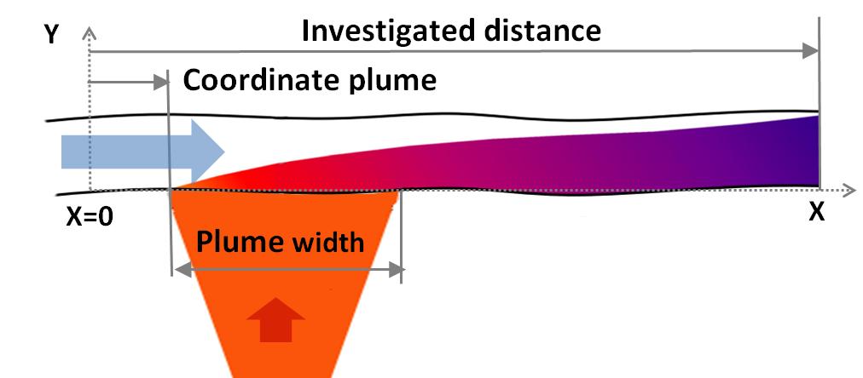

**Seepage location: Bank / half streambed**

1. Appendix B output file

Extract of txt output file



Y coordinate (transverse stream)

X coordinate (longitudinal stream)